## 实验五Tkinter图形界面设计

1. **实验目的**

熟练Tkinter库，能熟练运用Tkinter库中的各类控件开发图形界面

**（二）实验内容**

1. 设计一个课程类，包括课程编号、课程名称、任课教师、上课地点等成员，其中上课地点是私有的。添加构造方法及显示课程信息的方法，最后在主模块中定义类的对象，测试所设计的方法并显示最后结果。

|  |
| --- |
| class Class:  def __init__(self,numble,name,teacher,place):  self.numble = numble  self.name = name  self.teacher = teacher  self._place = place  def printclass(self):  return '课程编号:{}、课程名称:{}、任课教师:{}、上课地点:{}.'.format(self.numble,self.name,self.teacher,self._place)  a = Class(1,'python','老师','学校')  print(a.printclass()) |

1. 设计一个Date类，属性包括year、month、day三个属性和能够实现取日期、取年份、取月份、设置日期、输入日期的方法。

|  |
| --- |
| class Date:  def __init__(self,year,month,day):  self.year = year  self.month = month  self.day= day  def timeday(self):  return self.day  def timeyear(self):  return self.year  def timemonth(self):  return self.month    def settime(self):  year = int(input("请输入年份："))  month = int(input("请输入月份："))  day = int(input("请输入天："))  self.year = year  self.month = month  self.day= day  return "设置成功！"  def inputtime(self):  year = int(input("请输入年份："))  month = int(input("请输入月份："))  day = int(input("请输入日："))  self.year = year  self.month = month  self.day = day  return '输入完成!'  def printdata(self):  return "日期：{}.{}.{}".format(self.year,self.month,self.day)  data = Date(2021,5,1)  print('初始化'+data.printdata())  print('年:{}，月：{}，日：{}'.format(data.timeyear(),data.timemonth(),data.timeday()))  print(data.settime())  print('设置后'+data.printdata())  print(data.inputtime())  print('输入后'+data.printdata()) |

1. 设计一个程序，用两个文本框输入数值数据，用列表框存放加、减、乘、除、幂次方、余数。用户先输入两个操作数，再从列表框中选择一种运算，即可在标签中显示出计算结果。

|  |
| --- |
| from tkinter import *  import tkinter as tk  root=Tk()  m=StringVar()  def callbutton2():  a=float(num1.get())  b=float(num2.get())  for i in lb.curselection():  if lb.get(i)=='加':  print(a+b)  result["text"]=str(a+b)  if lb.get(i)=='减':  print(a-b)  result["text"]=str(a-b)  if lb.get(i)=='乘':  print(a*b)  result["text"]=str(a*b)  if lb.get(i)=='除':  print(a/b)  result["text"]=str(a/b)  if lb.get(i)=='幂次方':  print(a**b)  result["text"]=str(a**b)  if lb.get(i)=='余数':  print(a%b)  result["text"]=str(a%b)  root.title("计算器")  lab1=Label(root,text='操作数1',width=10)  lab1.pack()  num1 = tk.Entry(root)  num1.pack()  lab2=Label(root,text='操作数2',width=10)  lab2.pack()  num2 = tk.Entry(root)  num2.pack()  lb=Listbox(root,listvariable=m)  lb.insert(END,'加')  lb.insert(END,'减')  lb.insert(END,'乘')  lb.insert(END,'除')  lb.insert(END,'幂次方')  lb.insert(END,'余数')  lb.pack()  b2=Button (root,text = '计算', command=callbutton2, width=20)  b2.pack()  result=Label(root,text = 'result',width=6)  result.pack()  root.mainloop() |

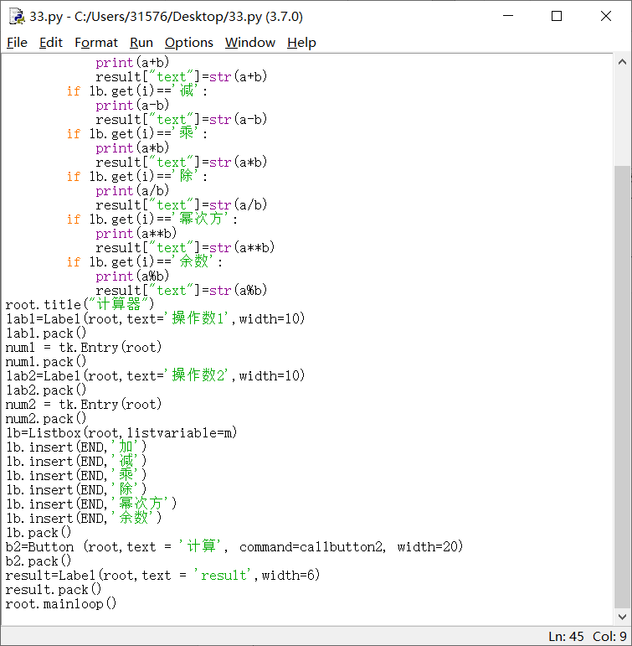

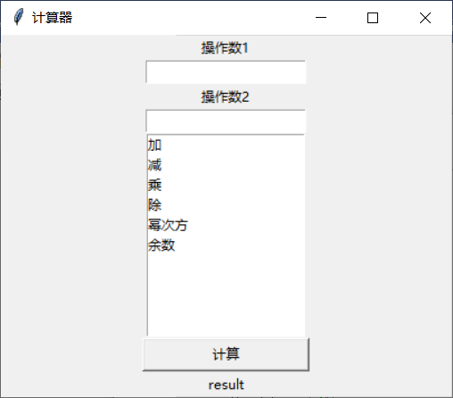

1. 设计一个倒计时程序，应用程序界面自己设计。

|  |
| --- |
| from tkinter import *  import time  class App:  def __init__(self,master):  frame = Frame(master)  frame.pack()  self.entryWidget = Entry(frame)  self.entryWidget.focus()  self.entryWidget["width"] = 15  self.entryWidget.pack(side=LEFT)  self.hi_there = Button(frame,text="Start",command=self.start)  self.hi_there.pack(side=LEFT)    def start(self):  text = self.entryWidget.get().strip()  if text != "":  num = int(text)  self.countDown(num)  def countDown(self,seconds):  lbl1.config(bg='yellow')  lbl1.config(height=3, font=('times',20,'bold'))  for k in range(seconds, 0, -1):  lbl1["text"] = k  root.update()  time.sleep(1)  lbl1.config(bg='red')  lbl1.config(fg='black')  lbl1["text"] = "Time up!"  root = Tk()  root.title("计时器")  lbl1 = Label()  lbl1.pack(fill=BOTH, expand=1)  app = App(root)  root.mainloop() |

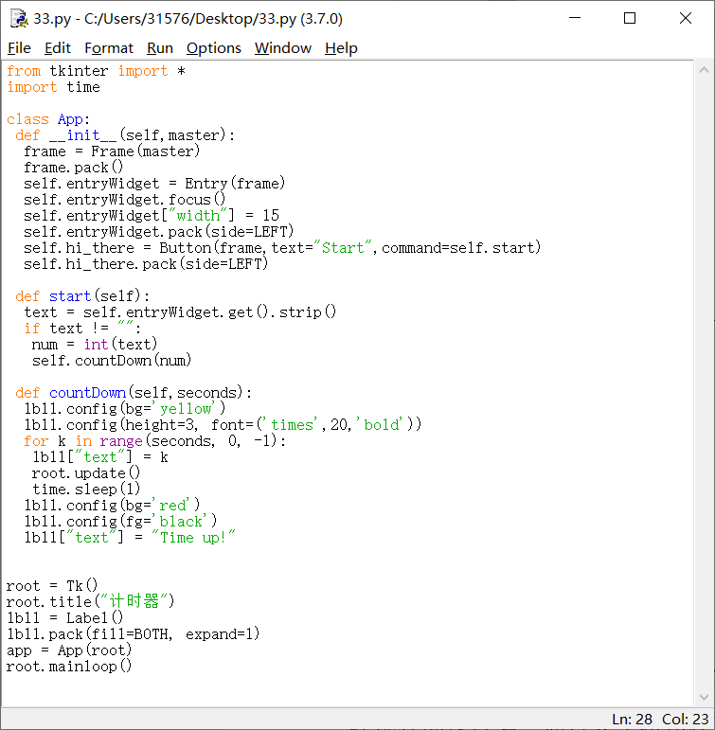

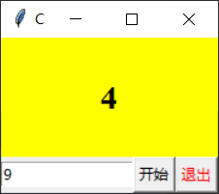

1. 编写选课程序。左侧列表框显示学生可以选择的课程名，右侧列表框显示学生已经选择的课程名，通过4个按钮在两个列表中移动数据项。通过“>”、“<”按钮移动一门课程，通过“≥”“≤”按钮移动全部课程。

|  |
| --- |
| from tkinter import *  from tkinter import ttk  billwindows=Tk()  billwindows.title("选课系统")  def callbutton1():  for i in theLeftBox.curselection():  theRightBox.insert(0, theLeftBox.get(i))  theLeftBox.delete(i)  def callbutton2():  for i in theRightBox.curselection():  theLeftBox.insert(0, theRightBox.get(i))  theRightBox.delete(i)  def callbutton3():  for i in range(0, theLeftBox.size()):  theRightBox.insert(0, theLeftBox.get(i))  for i in range(theLeftBox.size() - 1, -1, -1):  theLeftBox.delete(i)  def callbutton4():  for i in range(0, theRightBox.size()):  theLeftBox.insert(0, theRightBox.get(i))  for i in range(theRightBox.size() - 1, -1, -1):  theRightBox.delete(i)  KCB=["Python程序设计","面向对象程序设计","计算机网络","单片机","手把手带你学会vue","keil从入门到进监狱"]  #billwindows.geometry('1200x800')  theRightBox = Listbox(billwindows)  theLeftBox = Listbox(billwindows)  for item in KCB:  theLeftBox.insert(END, item)  theLeftBox.grid(row=0, column=0, rowspan=4)  tb1 = Button(billwindows, text='>', bg="pink",command=callbutton1, width=20)  tb2 = Button(billwindows, text='<', bg="pink",command=callbutton2, width=20)  tb3 = Button(billwindows, text='>>', bg="pink",command=callbutton3, width=20)  tb4 = Button(billwindows, text='<<', bg="pink",command=callbutton4, width=20)  w=Label(billwindows,text="选课系统",relief="groove",borderwidth=8)  tb1.grid(row=0, column=1)  tb2.grid(row=1, column=1)  tb3.grid(row=2, column=1)  tb4.grid(row=3, column=1)  w.grid(row=4,column=1)  theRightBox.grid(row=0, column=2, rowspan=4)  billwindows.mainloop() |

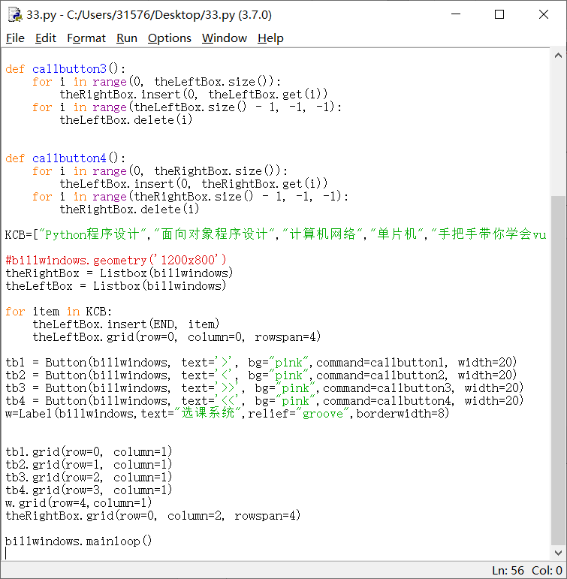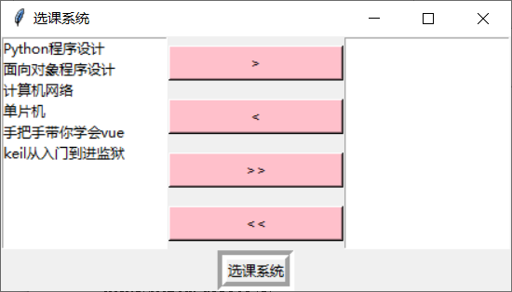

**（三）实验结果**

要求提交word文档，文档命名规则：姓名+学号+实验次数.doc

内容包含：

* 实验题目
* 源代码
* 运行结果截屏